# **Related imageCAPSTONE PROJECT 1: FINAL PROJECT**

Predicting House Price

Mehreteab Kidane

Springboard

June, 2019

**Introduction**

Over the past few decades, the housing price has shown increments as times goes by. It is no doubt that the longer the period of time the higher the price of housing. This is a big issue to be taken into consideration. It is considered an important issue because house is one of the important basic human needs. Therefore, being concerned about the housing price is a must and the factors that contribute to the increase of housing price need to be determined.

The following are the objectives of this project:

1. To determine the causes of increase in housing price.

2. To predict the price of housing price in the future.

3. To identify the effect of increase in housing price.

**Overview of Data**

This project illustrates different approaches to predict house prices using machine learning tools and forecasting algorithms to uncover what really influences the value of a house and achieve the high degree of accuracy in my model. The original dataset can be found [***Link***](https://www.kaggle.com/c/house-prices-advanced-regression-techniques/data) , in the Kaggle website. This dataset will allow us to learn more about the Housing market and to explore more deeply the most popular machine learning techniques, as well as learning more about the necessary steps to follow in a data science project.

**Significance of the Problem**

By doing prediction on the housing price, the factors that lead to the increase of housing price can be determined. The housing price in the future can be forecasted as well. The importance of doing this proposal on the housing price is that, it will give positive impact to the government. It can help the government to predict or estimates the price of housing in the future. These can wider the awareness of the price of housing which is now in high rate. This research will also can be an advantage for the housing developers in determining the housing price by identification of the factors that lead to the housing price estimation. Moreover, this prediction is also important to individuals who will purchase house in the future. This will give awareness to the individual regarding the housing price and help them to figure out the best decision in purchasing a house.

**Deliverable**

The deliverables will be the codes and visualization techniques on GitHub in the form of Jupyter Notebooks, and a slide desk. This will include a report and I intend to write a documentation explaining the code and the results.

**Data cleansing and analysis**

Let’s analyze the dataset and take a closer look at its content. The aim here is to find details like the number of columns and other metadata which will help us to gauge size and other properties such as the range of values in the columns of the dataset.

*data.shape Read the data into a data frame*

*data = pd.read_csv('. ./input/kc_house_data.csv')*

To see the number of rows and columns in the dataset we can use the “shape” attribute as shown below:

*data.shape*

In the output you should see (21613, 21) which means that our algorithm has 21613 rows and 21 columns.

The description for the features is given below:

***id***:- It is the unique numeric number assigned to each house being sold.   
***date*** :- It is the date on which the house was sold out.   
 **price**: - It is the price of house which we have to predict so this is our target variable and apartment from it are our features.   
 ***bedrooms*** :- It determines number of bedrooms in a house.   
***bathrooms*** :- It determines number of bathrooms in a bedroom of a house.   
***sqft_living*** :- It is the measurement variable which determines the measurement of house in square foot.   
 ***sqft_lot*** : It is also the measurement variable which determines square foot of the lot.   
 ***floors***: It determines total floors means levels of house.   
 ***waterfront*** : This feature determines whether a house has a view to waterfront 0 means no 1 means yes.   
***view*** : This feature determines whether a house has been viewed or not 0 means no 1 means yes.   
 ***condition*** : It determines the overall condition of a house on a scale of 1 to 5.   
***grade*** : It determines the overall grade given to the housing unit, based on King County grading system on a scale of 1 to 11.   
***sqft_above*** : It determines square footage of house apart from basement.   
 ***sqft_basement*** : It determines square footage of the basement of the house.   
***yr_built*** : It determines the date of building of the house.   
***yr_renovated*** : It determines year of renovation of house.   
***zipcode*** : It determines the zip code of the location of the house.   
 ***lat*** : It determines the latitude of the location of the house.   
 ***long*** : It determines the longitude of the location of the house.   
***sqft_living15*** : Living room area in 2015(implies-- some renovations)   
 ***sqft_lot15*** : lotSize area in 2015(implies-- some renovations)

Let’s see how the dataset actually looks. To do so, we can use the “head()” function as shown below:

*data.head()*

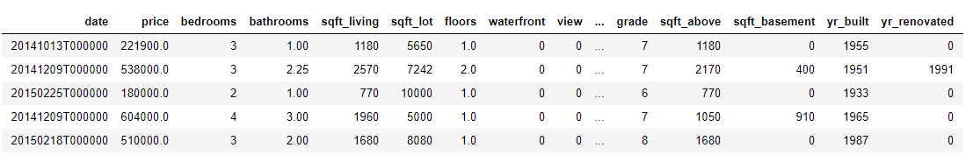

**To check if there are any null values in the dataset**

Now it’s time for some general data inspection. Let's first examine to see if there are any nulls in the dataframe as well as look at the type of the data (i.e whether it is a string or numeric)

*# Looking for nulls*

*print(data.isnull().any())*

*# Inspecting type*

*print(data.dtypes)*

The data is pretty clean. There are no pesky nulls which we need to treat and most of the features are in numeric format. Let's go ahead and drop the "id" and "date" columns as these 2 features will not be used in this analysis.

**Missing Data**

The answer to these questions is important for practical reasons because missing data can imply a reduction of the sample size. This can prevent us from proceeding with the analysis. Moreover, from a substantive perspective, we need to ensure that the missing data process is not biased and hiding an inconvenient truth. The good news is our data set contains no missing values.

*#missing data*

*total = df_house.isnull().sum().sort_values(ascending=False)*

*percent = (df_house.isnull().sum()/df_house.isnull().count()).sort_values(ascending=False)*

*missing_data = pd.concat([total, percent], axis=1, keys=['Total', 'Percent'])*

*missing_data.head(20)*

**Outliers Detection**

Outliers were detected and analyzed using the outlier box plots. From the outlier box plot I inferred that the data consist of many outliers for the target and price variables. However the outliers for the price variable corresponded to outliers for Numbers of bedrooms, number of bathrooms and square feet living.

**Exploratory Data Analysis Inferential Statistics**

From the dataset the most expensive house is priced at 7,700,000 and the least expensive house is priced 75,000. The average or mean price of a house is 540,088.14 and the median price of a house is 450,000. I plotted the histogram of price and it is right skewed. This indicates that there might be some outliers in the dataset. I also plotted a boxplot of price to check for outliers and found there are some outliers. Then I checked for outliers for other features like the number of bedrooms, the number of bathrooms, sqft_living, sqft_lot, floors, condition, grade, sqft_above, sqft_basement. Except for the column number of floors all other columns show that there might be some outliers. Then I converted the date column from string to datetime data type. Then I checked how many houses were sold in 2014 and 2015. There were 14633 houses sold in the year 2014 and 6980 houses sold in the year 2015.

To gain a sense of the relationship of the features with each other and with house prices, the target variable, I tried to use a diverse set of data visualization tools, including the following boxplots, histogramplots, scatter plots and correlation plots. The first EDA I performed was to examine the distribution of the home sale prices. The price of a house is dependent on various factors like size of area, how many bedrooms, location and many other factors. I conducted a hypothesis test to check if there is no significant correlation between a number of bedrooms and price. The p-value for the hypothesis test is less than the level of significance 0.05, so I rejected the null hypothesis. So I support that there is a correlation between a number of bedrooms and price. I also conducted a hypothesis test to check the correlation between a number of bathrooms and price. The p-value for the hypothesis test is less than the level of significance 0.05, so I reject the null hypothesis and suggest that there is a correlation between a number of bathrooms and price.

I started with the histograms of dataframe

*df=df[['price', 'bedrooms', 'bathrooms', 'sqft_living',*

*'sqft_lot', 'floors', 'waterfront', 'view', 'condition', 'grade',*

*'sqft_above', 'sqft_basement', 'yr_built', 'yr_renovated', 'zipcode',*

*'lat', 'long', 'sqft_living15', 'sqft_lot15']]*

*h = df.hist(bins=25,figsize=(16,16),xlabelsize='10',ylabelsize='10',xrot=-15)*

*sns.despine(left=True, bottom=True)*

*[x.title.set_size(12) for x* ***in*** *h.ravel()];*

*[x.yaxis.tick_left() for x* ***in*** *h.ravel()];*

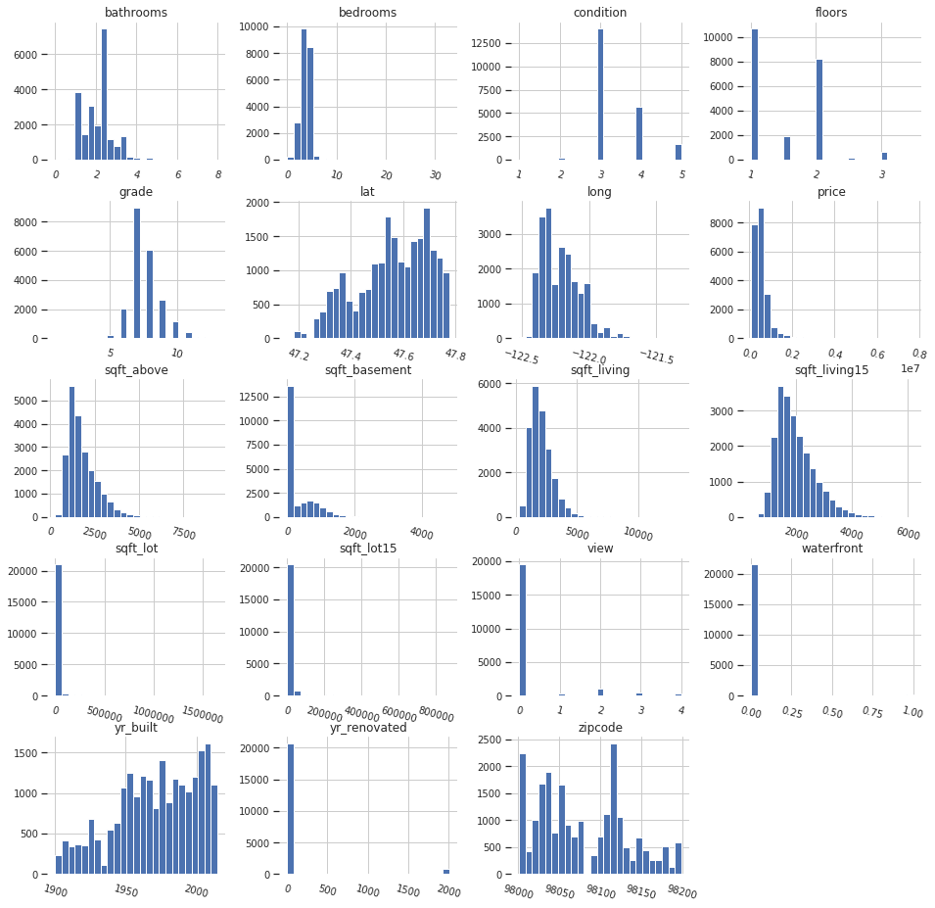

To determine bedrooms, floors or bathrooms/bedrooms vs price, I preferred **boxplot** because we have numerical data but they are not continuous as 1, 2... bedrooms, 2.5, 3... floors

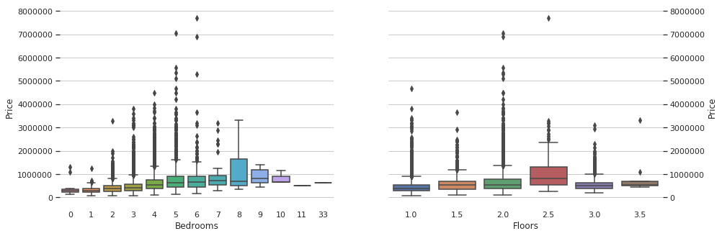



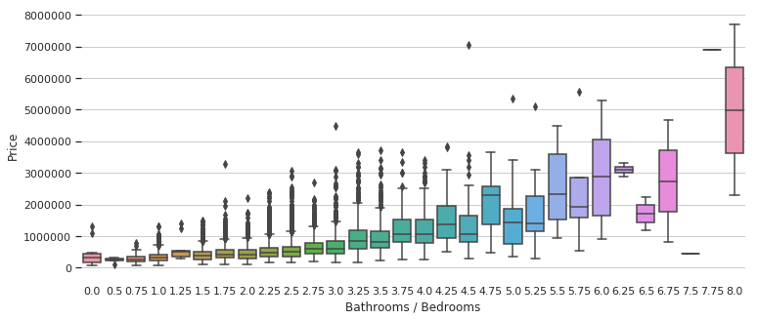

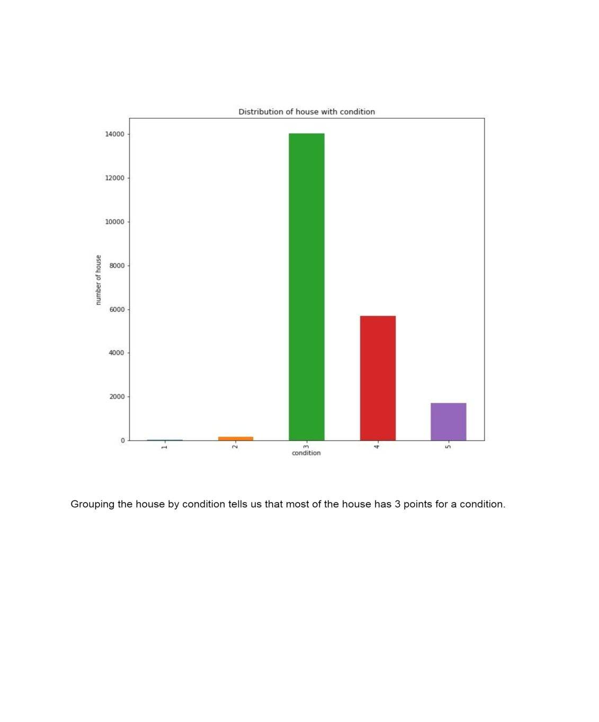

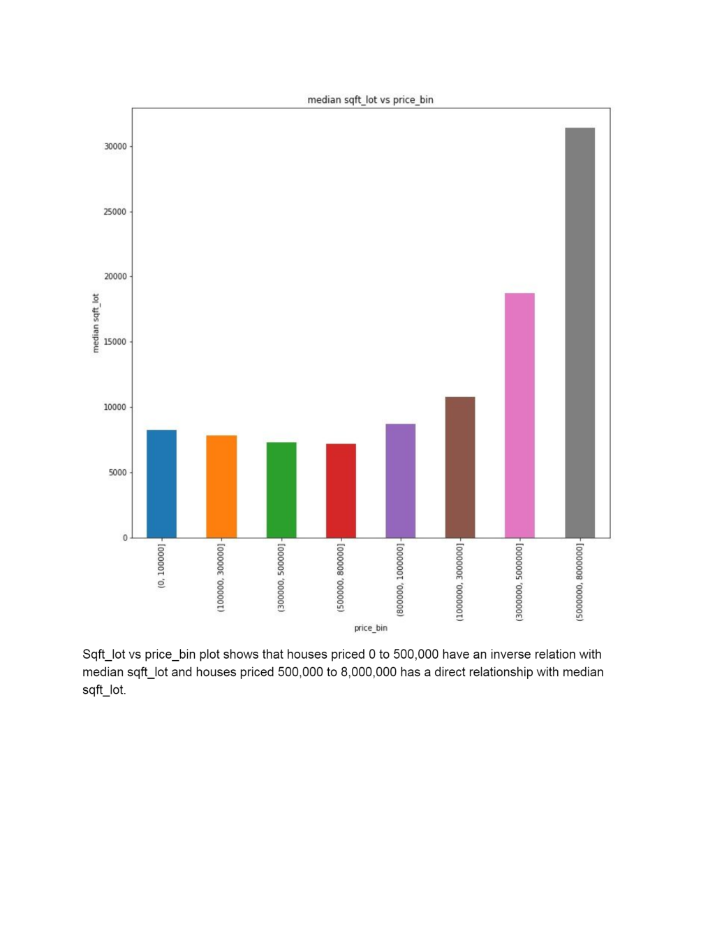

**Price vs. Square Feet Living**

The below scatterplots is indicative of house price increase with increase in square foot living and number of bathrooms. Home prices below 500,000 dollars have less than 2500 Square foot living area and have less than 3 bathrooms.

*var = 'sqft_living15'*

*data = pd.concat([data['price'], data[var]], axis=1)*

*data.plot.scatter(x=var, y='price', ylim=(3,9000000));*

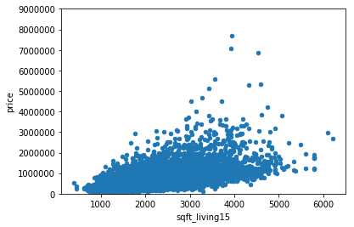

Similarly, I conducted a hypothesis test to check the correlation between sqft_living and price. The p-value for the hypothesis test is less than the level of significance 0.05, so I reject the null hypothesis and suggest that there is a correlation between sqft_living and price. I also conducted a hypothesis test to check if there is a correlation between grade and price. The test suggests that there is correlation between grade and price. I also conducted a hypothesis test to check if there is no statistical importance between mean house price and a number of bedrooms less than 3 and greater than 3. The p-value for the test is greater than the level of significance 0.05, so I fail to reject the null hypothesis. This suggests us that there is no statistical importance between mean house price and a number of bedrooms less than 3 and greater than 3.

**Predictive Modeling**

There are different machine learning algorithms to predict the house prices. In this project I will use two regression algorithms to train machine learning models. The models used are Linear Regression and Random Forest Regression.

The motivation for choosing those regression algorithms are both can accurately predict the trends when the underlying process is linear. There are many factors affect house prices, such as numbers of bedrooms and bathrooms. In addition, choosing different combinations of parameters in Linear Regression will also affect the predictions greatly.

**Splitting Data into Training and Testing Set**

The training dataset and test dataset must be similar, usually have the same predictors or variables. They differ on the observations and specific values in the variables. If you fit the model on the training dataset, then you implicitly minimize error or find correct responses. The fitted model provides a good prediction on the training dataset. Then you test the model on the test dataset. If the model predicts good also on the test dataset, you have more confidence. You have more confidence since the test dataset is similar to the training dataset, but not the same nor seen by the model. It means the model transfers prediction or learning in real sense.

So, by splitting dataset into training and testing subset, I can efficiently measure my trained model since it never sees testing data before. Thus it's possible to prevent overfitting.

I am just splitting dataset into 20% of test data and remaining 80% will used for training the model.

X_train, X_test, y_train, y_test = cross_validation.train_test_split(X, y ,test_size = 0.2)

**Feature Importance**

After splitting let’s identify the most important fractures in our dataset that contribute most to my prediction variable. Irrelevant features would decrease accuracy especially for linear algorithms like linear regression.

* Reduce Overfitting : Less redundant data means less opportunity to make decisions based on noise
* Improve accuracy : Less misleading data means modeling accuracy improves
* Reduce Training Time : Less data means that algorithms train faster

**Applying Machine Learning Model**

1. *Linear Regression*

from sklearn.linear_model import LinearRegression

regressor = LinearRegression ()

regressor.fit (train_features, train_labels)

I trained my model on the training set using the “fit()” method of the LinearRegression class from the sklearn.linear_model module.

Next, I need to make predictions on the test set. To do so, execute the following script:

predicted_price = regressor.predict(test_features)

Now my model has been trained, the next step is to evaluate the performance of the model. The metrics used for the evaluation of linear regression model are [root-mean-square error](https://en.wikipedia.org/wiki/Root-mean-square_deviation) **(*RMSE*)**, [mean squared error](https://en.wikipedia.org/wiki/Mean_squared_error) **(*MSE*)**, and [mean absolute error](https://en.wikipedia.org/wiki/Mean_absolute_error) **(*MAE*)**.

The following script finds the value for these metrics for the linear regression algorithm:

from sklearn import metrics

print(‘Mean sAbsolute Error:’, metrics.mean_absolute_error( test_labels, predicted_price))

print(‘Mean Squared Error:’, metrics.mean_squared_error(test_labels,predicted_price))

print(‘Root Mean Squared Error:’, np.sqrt(metrics.mean_squared_error(test_labels, predicted_price)))

The output looks like this:

Mean Absolute Error: 126522.39741578815

Mean Squared Error: 39089803087.07735

Root Mean Squared Error: 197711.41364897817

The lesser the values for these metrics, the better is the performance of the algorithms. Let’s see how random forest regressor performs on this data and compare the two algorithms.

1. *Random Forest Regressor*

Different kinds of models have different advantages. The random forest model is very good at handling tabular data with numerical features, or categorical features with fewer than hundreds of categories. Unlike linear models, random forests are able to capture non-linear interaction between the features and the target.

Execute the following script to train the machine learning model using Random Forest Regressor.

from sklearn.ensemble import RandomForestRegressor

regressor = RandomForestRegressor(n_estimators=200, random_state=0)

regressor.fit(train_features, train_labels)

*The next step is to predict the output values:*

predicted_price = regressor.predict(test_features)

And finally, the script below finds the performance metrics values for the random forest algorithm:

from sklearn import metrics

print(‘Mean Absolute Error:’, metrics.mean_absolute_error( test_labels, predicted_price))

print(‘Mean Squared Error:’, metrics.mean_squared_error(test_labels,predicted_price))

print(‘Root Mean Squared Error:’, np.sqrt(metrics.mean_squared_error(test_labels, predicted_price)))

*The output of the script above looks like this:*

Mean Absolute Error: 70467.01934555387

Mean Squared Error: 16251802750.754648

Root Mean Squared Error: 127482.55861393215

**Conclusion**

From the output, it is visible that the random forest algorithm is better at predicting house prices for the Kings County housing dataset, since the values of MAE, RMSE, and MSE for random forest algorithm are far less compared to the linear regression algorithm.